
Selected Topics: Deep Learning
Course Project

Supervision
Dr. Hossam Hawash
Eng. Mohamed Tarek

Team
Abdelrahman Omar Ali | 191900004
Mohamed Safwat Hassan | 192100140
Moomen Diaa Elbanna | 191800129
Abdallah Abdelmonem Abdelaziz | 192100154
Osama Abdelhakem Mohamed | 192100032

Abstract
Plant diseases represent a major challenge in agriculture due to their impact on crop quality, crop productivity, and economic sustainability. Traditional disease identification methods rely heavily on human expertise and manual inspection, which may be time-consuming and inaccurate in large-scale agricultural environments.
This project presents a deep learning-based approach for automatic plant leaf disease classification using image processing and convolutional neural networks. Two independent classification systems were developed:
- A custom Convolutional Neural Network (CNN) for Rice Leaf Disease Classification.
- A transfer learning model using EfficientNet-B1 for Mango Leaf Disease Classification.
The proposed systems utilize image preprocessing, augmentation techniques, deep learning training pipelines, and evaluation metrics to classify plant diseases accurately. Experimental results demonstrated excellent performance for both models, achieving high accuracy, strong generalization capability, and low computational cost.
Additionally, the project includes computational efficiency analysis using FLOPs, parameter count, training time, energy consumption, and carbon emission tracking. A Streamlit-based graphical user interface (UI) was also developed to allow users to test trained models using uploaded leaf images.

Chapter 1 — Introduction
1.1 Background
Agriculture plays a critical role in supporting food production and global economic stability. Plant diseases significantly affect agricultural productivity and can lead to major crop losses if not detected early. Farmers often depend on visual inspection for disease diagnosis, which may result in delayed treatment or incorrect classification.
Recent advances in deep learning and computer vision have enabled automatic disease recognition systems capable of identifying plant diseases from leaf images with high accuracy. Convolutional Neural Networks (CNNs) have become one of the most effective techniques for image classification tasks due to their ability to automatically extract visual features.
This project explores the application of deep learning models for plant leaf disease classification using two different approaches:
- Building a CNN model from scratch.
- Using transfer learning with a pretrained EfficientNet-B1 model.

1.2 Problem Statement
Manual identification of plant diseases can be difficult, time-consuming, and dependent on agricultural expertise. The goal of this project is to develop automated systems capable of classifying plant diseases from leaf images efficiently and accurately.

1.3 Objectives
The objectives of this project are:
- Develop a custom CNN model for rice leaf disease classification.
- Develop a transfer learning model using EfficientNet-B1 for mango leaf disease classification.
- Apply preprocessing and augmentation techniques to improve model performance.
- Evaluate model performance using multiple classification metrics.
- Analyze computational efficiency using FLOPs and parameter count.
- Measure energy consumption and carbon emissions during training.
- Build a graphical user interface for model testing.

1.4 Project Contributions
The main contributions of this project include:
- Development of two independent deep learning classification systems.
- Comparison between custom CNN architectures and transfer learning approaches.
- Integration of sustainability metrics including energy usage and carbon emissions.
- Development of a user-friendly testing interface using Streamlit.

Chapter 2 — Literature Review
2.1 Deep Learning in Agriculture
Deep learning techniques have shown significant success in agricultural applications including crop monitoring, disease detection, weed recognition, and yield prediction. Image classification models are widely used to identify plant diseases from leaf images due to their ability to learn complex visual patterns.
CNN-based architectures can automatically extract hierarchical features such as texture, edges, spots, and color patterns from images, making them highly suitable for disease classification.

2.2 Convolutional Neural Networks (CNNs)
CNNs are specialized neural networks designed for image processing tasks. They consist of multiple layers such as:
- Convolutional layers
- Activation layers
- Pooling layers
- Fully connected layers
These networks learn visual representations automatically without manual feature engineering.

2.3 Transfer Learning
Transfer learning is a deep learning approach where a pretrained model trained on a large dataset such as ImageNet is reused for another classification task. Instead of training a model from scratch, the learned visual features are transferred to a new problem.
Transfer learning provides several advantages:
- Faster training
- Higher accuracy
- Reduced computational cost
- Better generalization
EfficientNet-B1 was selected in this project because of its strong classification performance and computational efficiency.

Chapter 3 — Datasets
3.1 Rice Leaf Disease Dataset
The rice leaf dataset contains images representing multiple rice plant diseases.
Classes
- Bacterial Blight
- Blast
- Brown Spot
- Tungro
The dataset was used for training the custom CNN model.
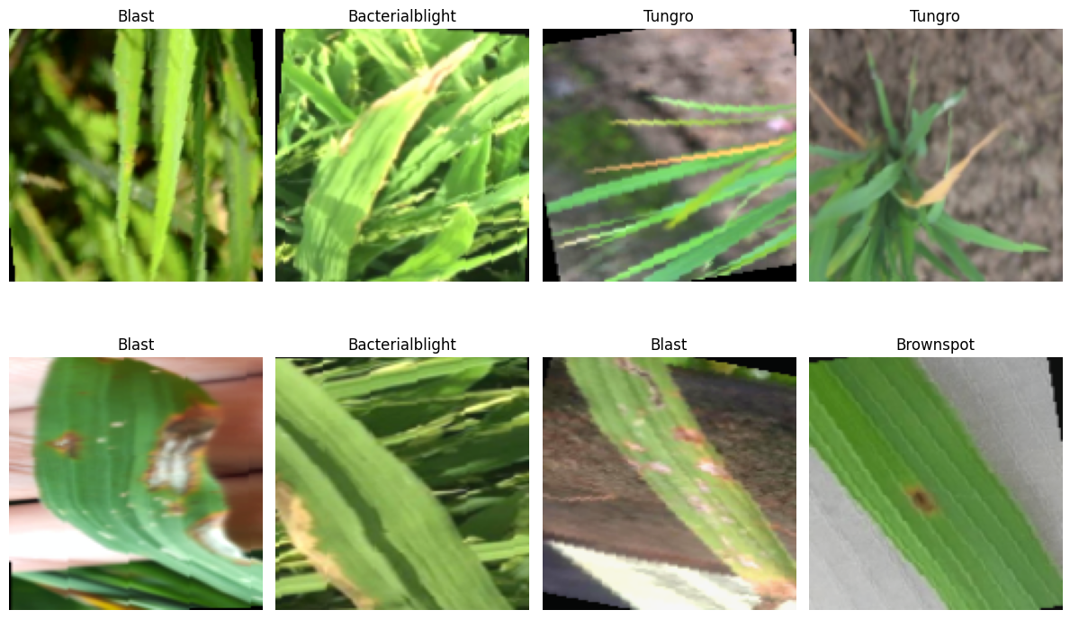
Sample images from the Rice Leaf Disease Dataset.

3.2 Mango Leaf Disease Dataset
The mango leaf dataset contains images representing healthy and diseased mango leaves.
Classes
- Anthracnose
- Bacterial Canker
- Cutting Weevil
- Die Back
- Gall Midge
- Healthy
- Powdery Mildew
- Sooty Mould

The dataset was used for training the EfficientNet-B1 transfer learning model.
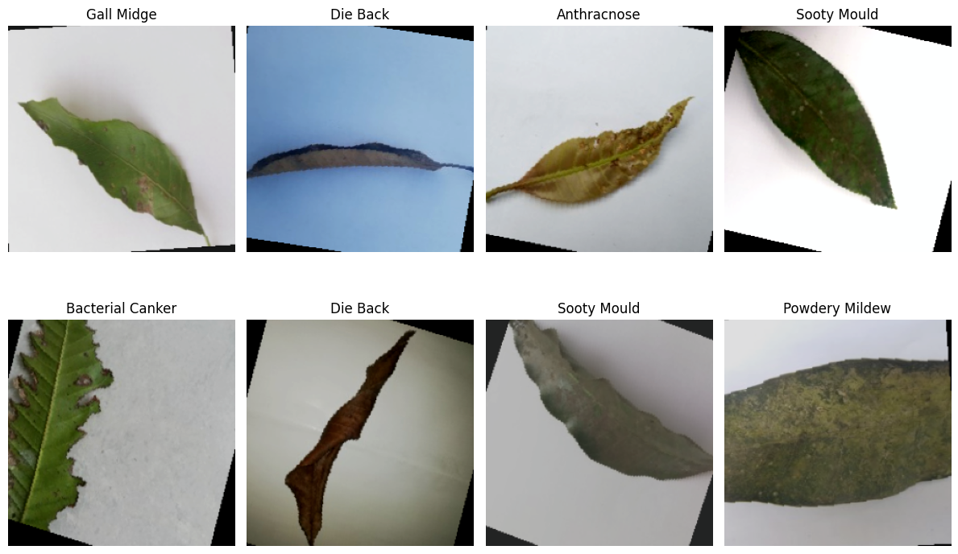
Sample images from the Mango Leaf Disease Dataset.

Chapter 4 — Data Preprocessing and Augmentation
4.1 Image Preprocessing
Image preprocessing was performed to improve image quality and prepare the dataset for training.
The preprocessing steps included:
- Image resizing
- Image normalization
- Tensor conversion
For the custom CNN model, images were resized to:
- 128 × 128 pixels
For EfficientNet-B1:
- 240 × 240 pixels

4.2 Data Augmentation
Data augmentation techniques were applied to improve model generalization and reduce overfitting.
The following augmentation methods were used:
- Random horizontal flipping
- Random rotation
- Random resized cropping
- Color jittering
These techniques help generate diverse training samples and improve model robustness.

Chapter 5 — Methodology
5.1 Rice Leaf Disease Classification Using Custom CNN
5.1.1 CNN Architecture
A custom Convolutional Neural Network was designed and implemented using PyTorch.
The architecture consists of:
- Four convolutional blocks
- Batch normalization layers
- ReLU activation functions
- Max pooling layers
- Fully connected classification layers
- Dropout layers for regularization

CNN Architecture Details
Layer | Description
Conv2D | 32 Filters
BatchNorm | Normalization
ReLU | Activation
MaxPooling | Downsampling
Conv2D | 64 Filters
Conv2D | 128 Filters
Conv2D | 256 Filters
Fully Connected | Classification

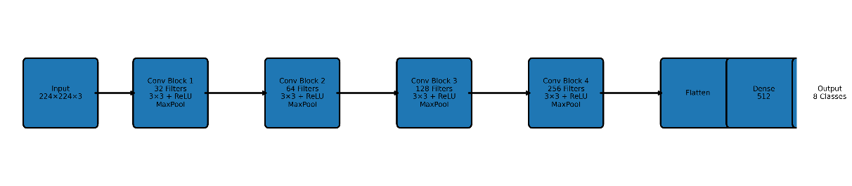
Architecture of the proposed custom CNN model.

5.1.2 Training Configuration
Parameter | Value
Optimizer | Adam
Learning Rate | 0.001
Batch Size | 32
Epochs | 30
Loss Function | CrossEntropyLoss

5.2 Mango Leaf Disease Classification Using EfficientNet-B1
5.2.1 EfficientNet-B1 Transfer Learning
EfficientNet-B1 is a pretrained deep learning architecture trained on the ImageNet dataset. Transfer learning was used by freezing the feature extraction layers and replacing the classification head with a custom classifier.
The model was fine-tuned for mango disease classification.

EfficientNet-B1 Advantages
- High classification accuracy
- Efficient parameter scaling
- Reduced computational complexity
- Strong feature extraction capability

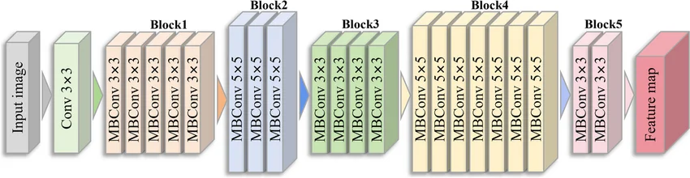
EfficientNet-B1 transfer learning architecture.

5.2.2 Training Configuration
Parameter | Value
Optimizer | Adam
Learning Rate | 0.001
Batch Size | 32
Epochs | 15
Loss Function | CrossEntropyLoss

Chapter 6 — Experimental Results
6.1 Rice Leaf Disease Classification Results
The custom CNN model achieved excellent performance on the rice disease classification task.
Evaluation Metrics
Metric | Value
Accuracy | 0.9978
Precision | 0.9978
Recall | 0.9978
F1 Score | 0.9978
Cohen Kappa | 0.9970
ROC-AUC | 1.0000

Learning Curves
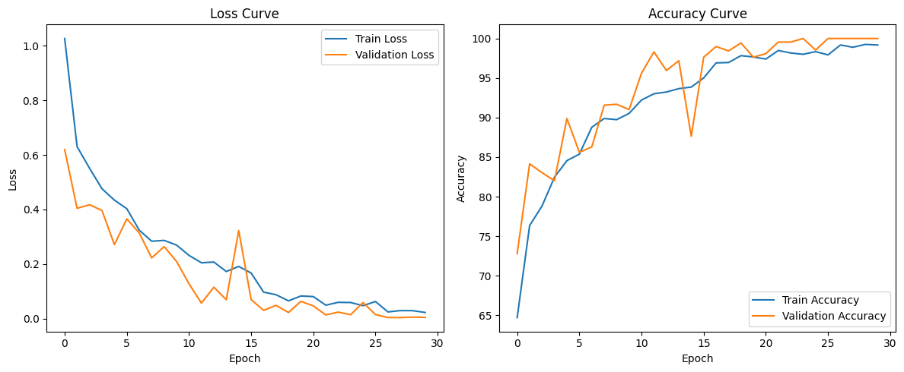
Training and validation learning curves for the custom CNN model.

Confusion Matrix
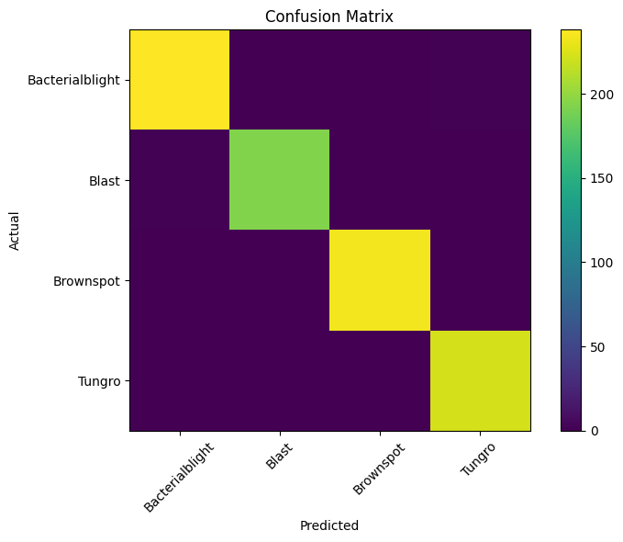
Confusion matrix for the Rice Leaf Disease Classification model.

6.2 Mango Leaf Disease Classification Results
The EfficientNet-B1 transfer learning model achieved near-perfect classification performance.
Evaluation Metrics
Metric | Value
Accuracy | 0.9917
Precision | 0.9918
Recall | 0.9917
F1 Score | 0.9917
Cohen Kappa | 0.9905
ROC-AUC | 1.0000

Classification Report
Class | Precision | Recall | F1-Score
Anthracnose | 0.99 | 0.98 | 0.98
Bacterial Canker | 1.00 | 1.00 | 1.00
Cutting Weevil | 0.99 | 1.00 | 0.99
Die Back | 1.00 | 1.00 | 1.00
Gall Midge | 0.97 | 1.00 | 0.99
Healthy | 1.00 | 0.99 | 0.99
Powdery Mildew | 1.00 | 0.98 | 0.99
Sooty Mould | 0.99 | 0.99 | 0.99

Confusion Matrix
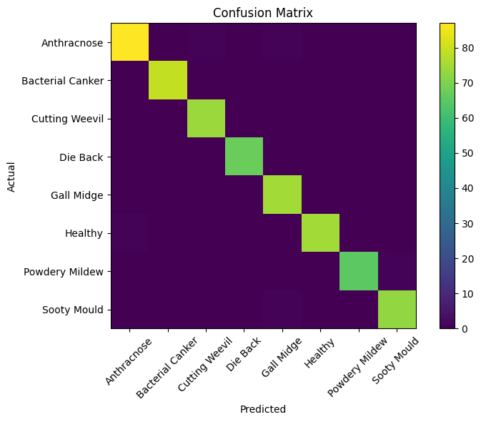
Confusion matrix for EfficientNet-B1 mango disease classification.

Learning Curves
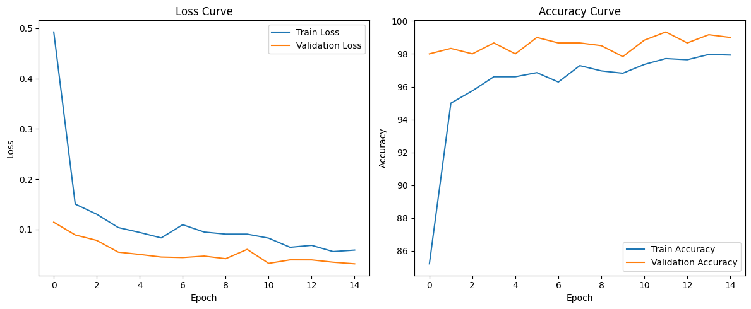
Training and validation learning curves for EfficientNet-B1.

Chapter 7 — Computational Performance Analysis
7.1 FLOPs and Parameters
Model | FLOPs | Parameters
Custom CNN | 0.253 GFLOPs | 8.911 Million
EfficientNet-B1 | 0.734 GFLOPs | 7.173 Million

7.2 Training Time
Model | Training Time
Custom CNN | 717.21 seconds
EfficientNet-B1 | 401 Seconds

7.3 Carbon Emissions
Energy consumption and carbon emissions were measured using the CodeCarbon library.
Model | Carbon Emissions
Custom CNN | 0.009779 kgCO2eq
EfficientNet-B1 | 0.001858 kgCO2eq

Chapter 8 — User Interface for Testing
8.1 Streamlit-Based UI
A graphical user interface was developed using Streamlit to allow users to test both trained models interactively.
The interface enables users to:
- Select the desired model
- Upload a leaf image
- Run prediction
- Display predicted disease class
- Display confidence score

8.2 User Interface Workflow
Steps
- Open the Streamlit application.
- Select either:
  - Rice Leaf Disease Model
  - Mango Leaf Disease Model
- Upload a leaf image.
- Click the Predict button.
- View prediction results.

8.3 UI Screenshots
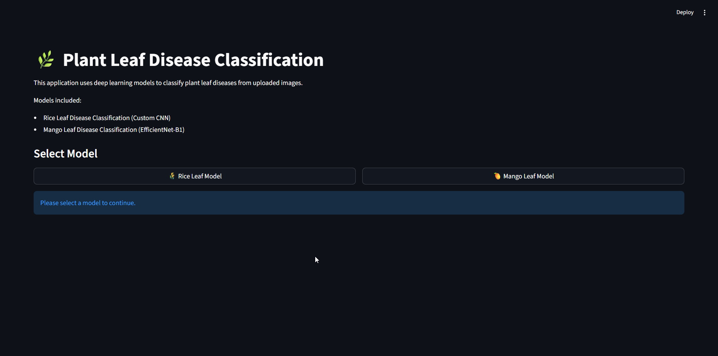
Main user interface.

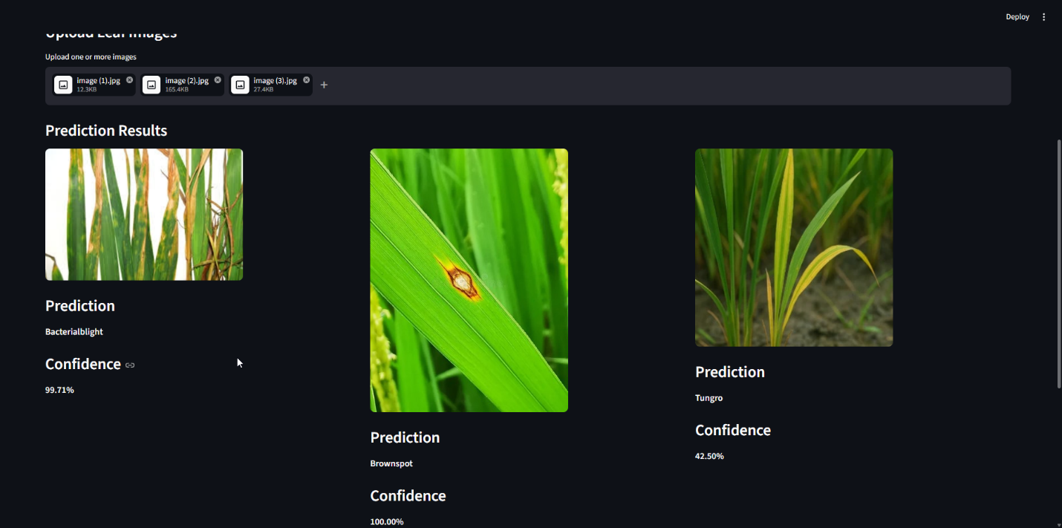
Example prediction using the developed interface.

Chapter 9 — Discussion
The experimental results demonstrate the effectiveness of deep learning techniques for plant disease classification.
The custom CNN model achieved excellent performance on the rice dataset while maintaining a relatively simple architecture. This demonstrates that carefully designed CNNs can perform effectively even without transfer learning.
EfficientNet-B1 achieved near-perfect classification accuracy on the mango dataset due to the advantages of transfer learning and pretrained feature extraction.
The confusion matrices showed minimal classification errors across classes, indicating strong generalization capability.
Additionally, the integration of computational metrics such as FLOPs, training time, and carbon emissions provided further insight into model efficiency and sustainability.

Chapter 10 — Conclusion
This project successfully implemented two deep learning systems for automatic plant leaf disease classification.
The first system used a custom CNN architecture for rice disease classification, while the second system used EfficientNet-B1 transfer learning for mango disease classification.
Experimental results demonstrated excellent classification performance, strong generalization, and efficient computational behavior.
The developed Streamlit interface also provided a practical and user-friendly testing environment for real-time disease prediction.
Future work may include:
- Deployment on mobile devices
- Real-time field testing
- Integration with IoT systems
- Larger agricultural datasets
- Disease severity estimation

